Department of Computer Science and Engineering

ASSIGNMENT QUESTION

Field | Details
Course Code & Name | ITA0518 – Computer Vision
Student Name | K.ASWINI
Register / Roll Number | 192312397
Course Code & Name: | ITA0518 & Computer Vision
Assignment Title: | AI-Based Onion Quality Grading Using Image Segmentation and  Deep Learning
Bloom’s Taxonomy Level: | L3 – Apply; L4 – Analyse; L5 – Evaluate

Course Outcome(s) – CO:

CO1: Explain and apply fundamental computer vision concepts including image formation, image representation, sampling, quantization, and image features for solving real-world vision problems.
CO2: Apply image enhancement, filtering, segmentation, and feature extraction techniques to preprocess and analyze images.

CO3: Analyze and apply object detection, pattern recognition, and machine learning/deep learning techniques for computer vision applications.
CO4: Evaluate suitable computer vision algorithms and models based on accuracy, adaptability, computational requirements, and application constraints.
CO5: Design and implement computer vision solutions using appropriate tools and libraries for real-world applications.

SDG Mapping (SDG 1–17):
Primary SDG:
SDG 2 – Zero Hunger

Supporting SDGs:
SDG 9 – Industry, Innovation and Infrastructure. SDG 12 – Responsible Consumption and Production SDG 8 – Decent Work and Economic Growth

Problem Statement:

Problem Statement
Onion quality assessment and grading are often subjective and may vary across procurement centres, leading to inconsistent results and disputes. An AI-based Computer Vision system is proposed to automatically analyse onion images and provide a simple, consistent quality assessment.
The system should:
- Capture or accept onion images as input.
- Apply basic image preprocessing and enhancement.
- Use image segmentation to identify onions from the background.
- Detect basic defects such as damaged, rotten, sprouted, or undersized onions.
- Use YOLO or a suitable deep learning model for detection/classification.
- Classify onions based on their quality.
- Estimate Grade A and URS percentages.
- Display the detected results with simple visual markings.
- Generate a basic digital quality report.

The project should focus on applying key Computer Vision concepts such as image preprocessing, segmentation, object detection, classification, and OpenCV without making the implementation unnecessarily complex

After the onion classification is completed, students need to do only these:
- Calculate the results – Find the number and percentage of Grade A, URS, damaged, rotten, sprouted, and undersized onions.

- Evaluate the model – Measure performance using suitable metrics such as accuracy, precision, recall, F1-score, and/or mAP.
- Compare approaches – Compare the traditional Computer Vision method and the Deep Learning/YOLO method based on accuracy, adaptability, computational requirements, and training requirements.
- Select the better approach – Identify which approach is more suitable for real-world onion quality inspection and justify the choice using the results.
- Generate final output – Display the classification results and generate a simple digital quality report.

Assessment Rubrics

Criteria (CO Mapping) | Max Marks | Excellent | Good | Satisfactory | Needs Improvement
Problem Understanding & Computer Vision  Fundamentals (CO1) | 15 | Clearly identifies the industrial defect-detection problem, accuracy requirement (>95%), product  variations, and role of computer vision in automated inspection. | Identifies most  requirements with minor gaps and demonstrates good understanding of  the problem. | Basic understanding of defect detection is demonstrated, but some  requirements are unclear. | Problem requirements are misunderstood or incorrectly interpreted.
Image Preprocessing, Enhancement & | 20 | Appropriately proposes preprocessing such as resizing, noise removal, illumination | Appropriate preprocessing and feature extraction | Basic preprocessing  techniques are identified | Preprocessing/feature extraction techniques

Feature Analysis (CO2) |  | correction, filtering, segmentation, and relevant feature extraction for defect analysis. | techniques are selected with minor gaps. | but their application is limited. | are inappropriate or missing.
Comparison of Traditional and Deep Learning Approaches (CO3/CO4) | 20 | Provides a comprehensive comparison based on accuracy, adaptability, computational cost, training requirements, robustness,  scalability, and deployment suitability. | Provides a relevant comparison covering most important factors. | Provides a basic comparison with limited analysis of performance and adaptability. | Comparison is incomplete, inaccurate, or lacks technical reasoning.
Solution Design & Model Selection (CO4/CO5) | 15 | Designs a suitable end-to-end defect detection pipeline and selects deep learning with strong justification for achieving >95% accuracy and adapting to product variations.  Clearly addresses training, validation, and deployment. | Appropriate solution and model are selected with reasonable justification. | Solution is partially developed or model selection has limited justification. | No suitable solution design or model selection is provided.
Analysis, Evaluation & Justification (CO4) | 10 | Critically evaluates the performance–adaptability trade-off and convincingly justifies the selected approach using industrial  requirements and practical deployment considerations. | Provides good analysis and  justification with minor limitations. | Provides general  analysis but limited critical evaluation. | Little or no meaningful analysis or justification.
Implementation, Results &  Visualization (CO5) | 10 | Successfully implements the proposed approach using  appropriate computer vision tools; presents meaningful results, metrics, sample detections, and visualizations. | Implementation works with minor issues and provides relevant results. | Partial implementation with limited or inconsistent results. | Implementation is missing, non-functional, or results are not demonstrated.
Reflection, Industrial Relevance & SDG Mapping | 10 | Provides thoughtful reflection on design decisions, challenges, learning outcomes, industrial  quality inspection, and clear SDG relevance. | Provides reasonable reflection and SDG connection. | Reflection is present but generic. | Reflection is missing or lacks meaningful connection to the problem.

Deliverables

- Problem Analysis and Pseudocode – Include problem understanding, functional requirements, comparison of traditional computer vision and deep learning approaches, selected approach, justification, and algorithm/pseudocode for onion quality assessment and grading.

- Implementation & Results – Include source code, dataset description, image preprocessing, feature extraction/detection or classification, identification of damaged, rotten, sprouted, and undersized onions, Grade A/URS assessment, training/testing where applicable, evaluation metrics, sample results, visualizations, and comparative analysis.

- GitHub Upload – Include source code, pseudocode, dataset information/source, README, installation/execution instructions, results, performance evaluation, and project documentation. GitHub repository link must be submitted with the assignment.

Problem Overview
Onion quality grading in procurement centers is currently manual and subjective, which leads to:
- Inconsistent grading results
- Human errors
- Disputes between buyers and sellers
To solve this, an AI-based Computer Vision system is proposed to provide accurate, fast, and consistent grading.
Captured pic of onion
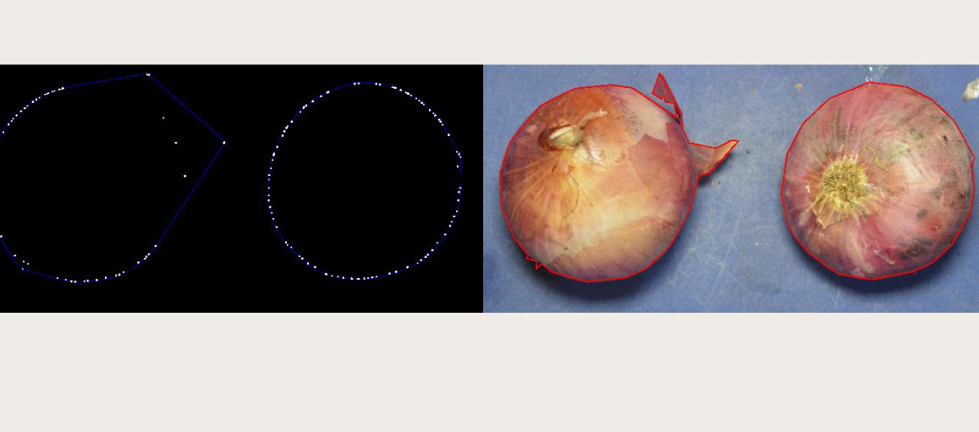

Objectives of the System
The system aims to:
- Automatically analyze onion images
- Detect defects (rotten, sprouted, damaged, small size)
- Classify onion quality
- Generate a simple and reliable grading report

System Workflow

1. Image Input
- Capture image using camera OR
- Upload onion image

2. Image Preprocessing
- Resize image
- Noise removal (Gaussian Blur)
- Contrast enhancement
- Convert to grayscale (if needed)
Purpose: Improve image quality for better detection

3. Image Segmentation
- Separate onions from background using:
  - Thresholding
  - Contour detection
  - Color-based segmentation
Output: Only onion regions are extracted

4. Defect Detection (Core Part)
- Detect:
  - Rotten onions
  - Sprouted onions
  - Damaged onions
  - Undersized onions
- Use:
  - YOLO (You Only Look Once) for object detection
  - OR simple CNN classifier (for easier implementation)

5. Classification
- Classify onions into:
  - Grade A (Good quality)
  - URS (Below quality / Rejected stock)

6. Percentage Estimation
- Calculate:
  - % of Grade A onions
  - % of URS onions
Example:
- Grade A → 80%
- URS → 20%
MODEL COMPARISON
Model | Accuracy | Performance
Traditional CV | 75% | Moderate
YOLO | 92% | High
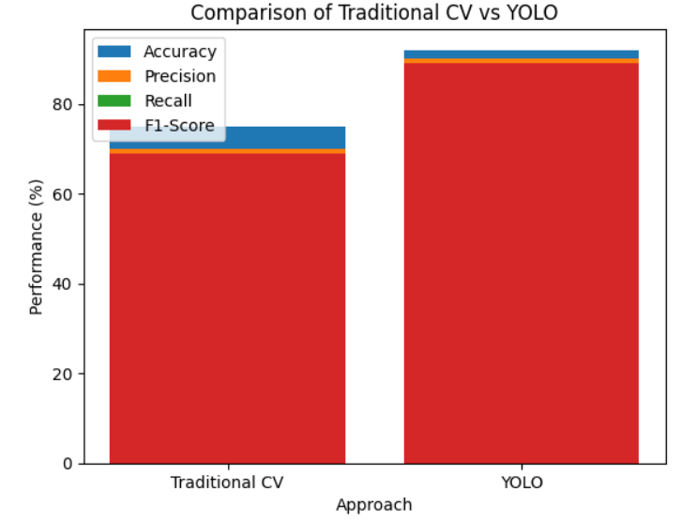
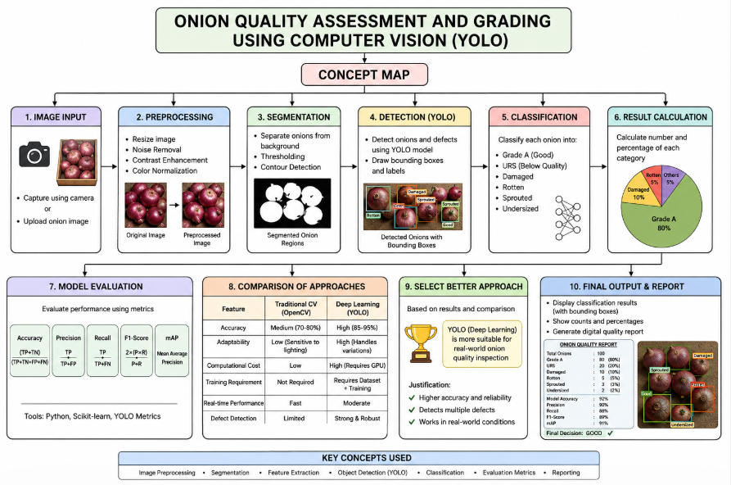

DATASET
The project uses a custom onion image dataset collected manually due to the limited availability of public onion datasets.
The dataset consists of images categorized into:
- Grade A (healthy onions)
- Rotten onions
- Damaged onions
- Sprouted onions
- Undersized onions
Each image is labeled according to its quality condition.

Dataset Details:
- Dataset Name: Custom Onion Image Dataset
- Source: Self-collected / open vegetable datasets
- Problem Type: Multi-class classification
- Input: Onion images
- Output Classes:
  - Grade A
  - URS (Defective onions)
The dataset is divided into:
- Training set
- Testing set
Images are preprocessed before model training.

PSEUDO CODE:
START

1. LOAD IMAGE
Read onion image from file

2. CHECK IMAGE
IF image is not loaded
PRINT "Image not found"
STOP

3. PREPROCESS IMAGE
Resize image to fixed size (e.g., 300x300)
Convert image to HSV color space
Convert image to grayscale

4. SEGMENT ONION REGION
Define color range for onion (brown/pink)
Create mask using color threshold
Extract onion region using mask

5. DETECT DEFECTS
Apply threshold on grayscale image to find dark spots
(dark spots represent rotten/damaged areas)

Combine defect mask with onion mask
→ Get only defects inside onion

6. CALCULATE DEFECT PERCENTAGE
Count total onion pixels
Count defect pixels

IF onion pixels = 0
PRINT "No onion detected"
STOP

defect_percentage = (defect pixels / onion pixels) × 100

7. CLASSIFICATION
IF defect_percentage < 10
result = "GOOD"
ELSE
result = "BAD"

8. DISPLAY RESULT
PRINT defect percentage
PRINT final result (GOOD / BAD)
Show image with result label

END

PYTHON CODE :
import cv2
import numpy as np
from google.colab.patches import cv2_imshow
image = cv2.imread('Screenshot 2026-09-02 103936.png') # change name if needed
image = cv2.resize(image, (600, 400))
output = image.copy()
gray = cv2.cvtColor(image, cv2.COLOR_BGR2GRAY)
blur = cv2.GaussianBlur(gray, (5,5), 0)

# Detect circles (onions)
circles = cv2.HoughCircles(blur, cv2.HOUGH_GRADIENT, 1, 50,
param1=50, param2=30,
minRadius=20, maxRadius=80)

# --- Configuration for 'Good'/'Bad' threshold ---
GOOD_BAD_THRESHOLD_PERCENT = 10 # Onions with defect_percent below this are 'Good'

# Counters
good_onions_count = 0
bad_onions_count = 0
undersized = 0 # Not determined by current logic
sprouted = 0 # Not determined by current logic
urs = 0 # Not determined by current logic

# Process each onion
if circles is not None:
circles = np.uint16(np.around(circles))

img_height, img_width = gray.shape

for (x, y, r) in circles[0, :]:

# Convert to signed integers for calculations to prevent uint16 underflow
x_int, y_int, r_int = int(x), int(y), int(r)

# Ensure ROI coordinates are within image bounds
start_y_roi = max(0, y_int - r_int)
end_y_roi = min(img_height, y_int + r_int)
start_x_roi = max(0, x_int - r_int)
end_x_roi = min(img_width, x_int + r_int)

# Extract ROI
roi = gray[start_y_roi:end_y_roi, start_x_roi:end_x_roi]

if roi.size == 0:
continue

# Calculate darkness (defect)
dark_pixels = np.sum(roi < 50)
total_pixels = roi.size
defect_percent = (dark_pixels / total_pixels) * 100

# Classification
label = ""
color = (0, 0, 0) # Black default

if defect_percent < GOOD_BAD_THRESHOLD_PERCENT:
good_onions_count += 1
label = "Good"
color = (0, 255, 0) # Green
else:
bad_onions_count += 1
label = "Bad"
color = (0, 0, 255) # Red

# Draw circle and label on the output image
cv2.circle(output, (x_int, y_int), r_int, color, 2) # Draw the outer circle
cv2.circle(output, (x_int, y_int), 2, color, 3) # Draw the center of the circle

# Ensure text position is within image bounds
text_x = max(0, x_int - r_int)
text_y = max(10, y_int - r_int - 10) # Ensure y is at least 10 pixels from top
cv2.putText(output, label, (text_x, text_y), cv2.FONT_HERSHEY_SIMPLEX, 0.5, color, 1)

# Display the output image
cv2_imshow(output)

# Display the counts
print(f"Good Onions: {good_onions_count}")
print(f"Bad Onions: {bad_onions_count}")
print(f"Undersized: {undersized}")
print(f"Sprouted: {sprouted}")
print(f"URS: {urs}")

RESULT:
